How to become a SMART Exemplary Educator 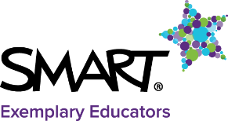

What is the SMART Exemplary Educator Program?  The heart of SMART, the SMART Exemplary Educator Program (SEE) is an exclusive group of passionate, enthusiastic, and dedicated teachers who change the world we live in, one student at a time.  Over 1400 SEEs in 40 different countries have already joined the program. 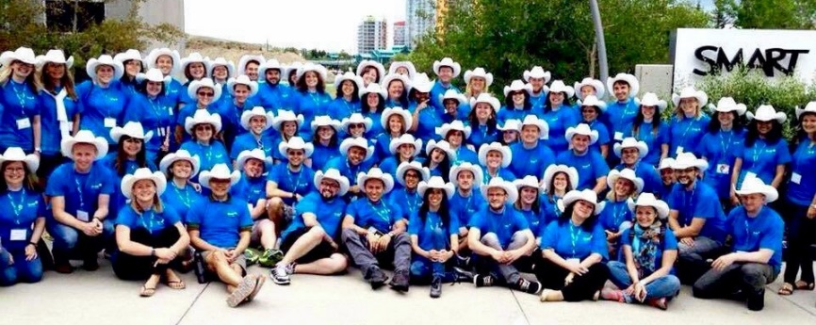  Who can apply?  The SEE program includes amazing educators from all over the world. These educators include librarians, teachers, professors, school administrators, principals,… who are passionate about SMART technology and how it enhances learning.  Apply now if you are…  - … a passionate teacher using SMART solutions in your classroom to improve your students learning.  - … an enthusiastic educator and you like to share your experience, your work and your enthusiasm around the world  - … an innovator and you create engaging, interactive learning experiences to prepare students for a better world | In their own words:  Staci Gelbaum, SEE in Georgia, USA  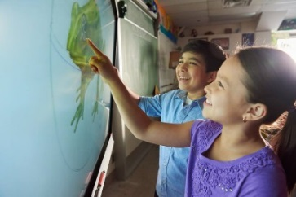  The SEE program is a program that allows teachers who are already doing amazing things in their classes to be recognized for their hard work. It is also an amazing professional community of teachers around the world that collaborate with one another on various projects for their schools and classes. The SEE program also helps developers at SMART to test products and software and provides feedback.  Bryony Drew, SEE in Scotland  Being a SEE has enabled me to meet and network with educators all over the world, engage my pupils in global collaborative activities and enables me to continue to develop my own skills and share my knowledge to develop the skills of other educators.

Why become a SMART Exemplary Educator  Becoming a SEE you will find opportunities to:  - Connect and collaborate with educators around the world over 1400 SEEs from 40 different countries  - Be inspired and motivated by others  - Opportunities for global collaborative projects  - Get connected  - Extend your PLN (Personal Learning Network)  - Be in contact with our developers and provide feedback to improve our solutions  - Participate in SMART Hackathons  - Have direct support in our private communities  - Provide your feedback and ideas to create new solutions and tools  - Be the first one to test our products!  - Get free software opportunities  - Receive invitation to events and special training and Professional Development opportunities  - Get access to special contest and prizes  - Be an exclusive member of our SEE Communities  - Google + SEE private group  - Gold Star SEE  - Receive international recognition on your education excellence: logos and certificates, badges and rewards  - Share your experience around the world  - Be featured in our publications and social media channels, EdBlog, webpage  - Success stories  - Publications  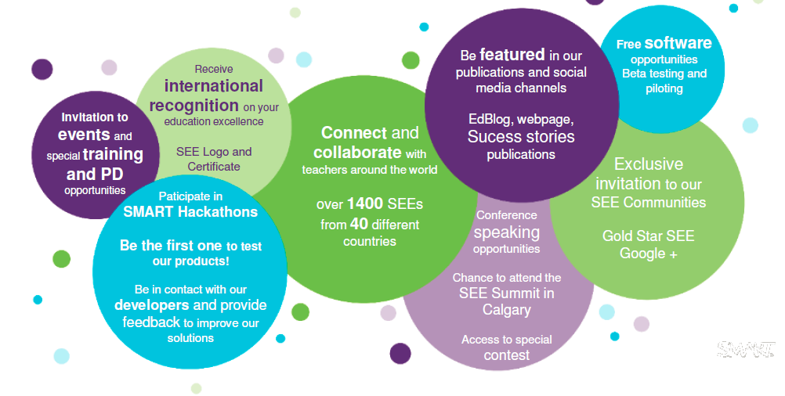 | 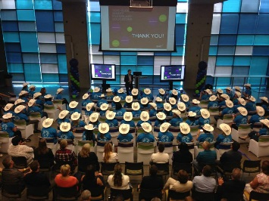  Maria Grazia Berardo, SEE in Italy  Being a SEE is an incredible experience, adventure and professional growth. Probably the best thing a teacher could imagine!  Kevin Willson, SEE in Pennsylvania, USA  By being part of the SEE program you continue to be motivated to try new things, keep up to date and share your questions and successes with the others SEE's, which makes you a better educator  Jorgen Holmberg, SEE in Finland  I have an international place where I am known and I can collaborate with other. It doesn't matter if I come from NYC or a small school with 60 students on the countryside in Finland

What sets a SEE apart from other teachers?  SMART Exemplary Educators are  - enthusiastic to share and disseminate their ideas and SMART experience and how SMART solutions can be used in the classroom to foster student creativity and innovation. They are open to teach others, receive visits in their classroom, present in conferences, share their SMART knowledge and ideas ...  - passionate about education and technology, SEEs think that they can take education to another level using SMART solutions  - innovative educators who constantly look at ways to best use technology to enhance students learning, willing to try new things and not afraid of new technologies  They love to learn and share, and they are highly motivated, engaged and connected.  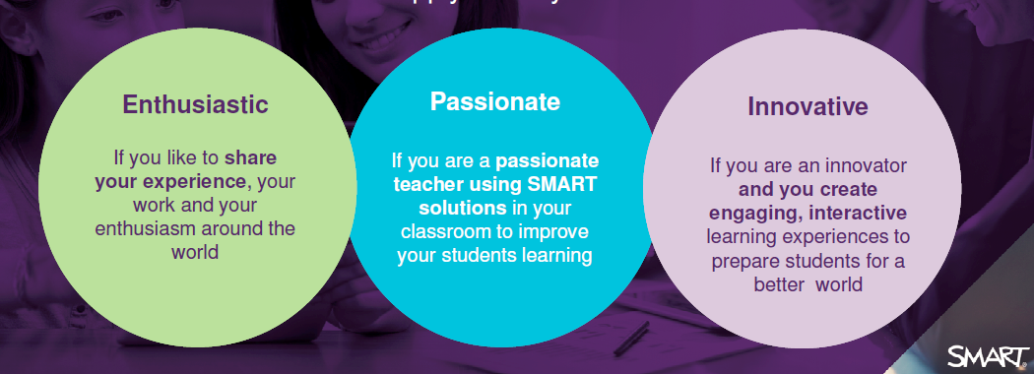  SMART Exemplary Educator application  There is an annually application to the SMART Exemplary Educator Program in Autumn. The rest of the year you can sign up to be notified when SMART is accepting applications for the program here.  Applicants will complete a series of questions which will include, but not limited to their classroom activities. As part of the process educators will be asked to tell us about themselves:  - Why would they like to be a SEE  - How do they use the SMART solutions  - Level of innovation by describing a class activity in which they have incorporated SMART solutions in an innovative way. | SEE Application process:  - Apply here or copy and paste the following link https://smarttech.co1.qualtrics.com/SE/?SID=SV_eM0QhdI3OGKRUeF  - Answer all questions  - Submit  - Cross fingers, we wish you the best!  Timeline:  October 12, 2015: applications open  November 30, 2015: applications close  December 17, 2015: confirmation emails  If you want to be a SEE apply now here  If know someone who should be there, don't hesitate to share this post and encourage them to apply.  Questions? Contact us SEEProgram@smarttech.com

